How to fix KVM permission denied error on Ubuntu 18.04
13 Aug 2018
/dev/kvm device: permission denied is the error that I got while trying to run Android Virtual Device(AVD) on a fresh install of Ubuntu 18.04.
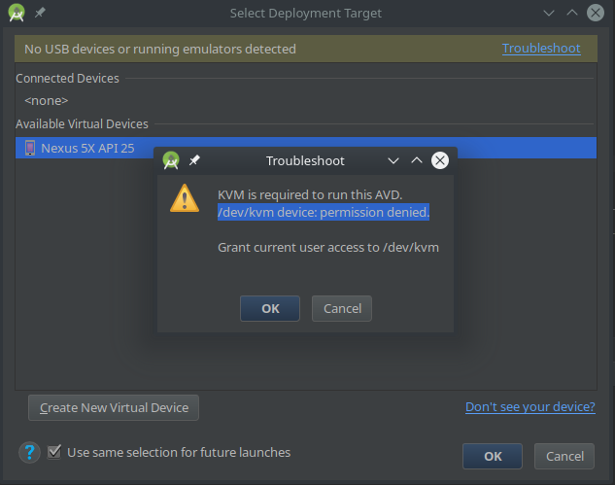
The error message also shows a hint on what could be wrong:Grant current user access to /dev/kvm.A quick google search reveals that this is a common problem.
The easiest way to fix this would be to install qemu-kvm and then give appropriate permission to the current user.
Install qemu-kvm.
$ sudo apt install qemu-kvm
Use the adduser command to add your user to the kvm group.
$ sudo adduser <username> kvm
And then own the file /dev/kvm using chown.
$ sudo chown <username> /dev/kvm
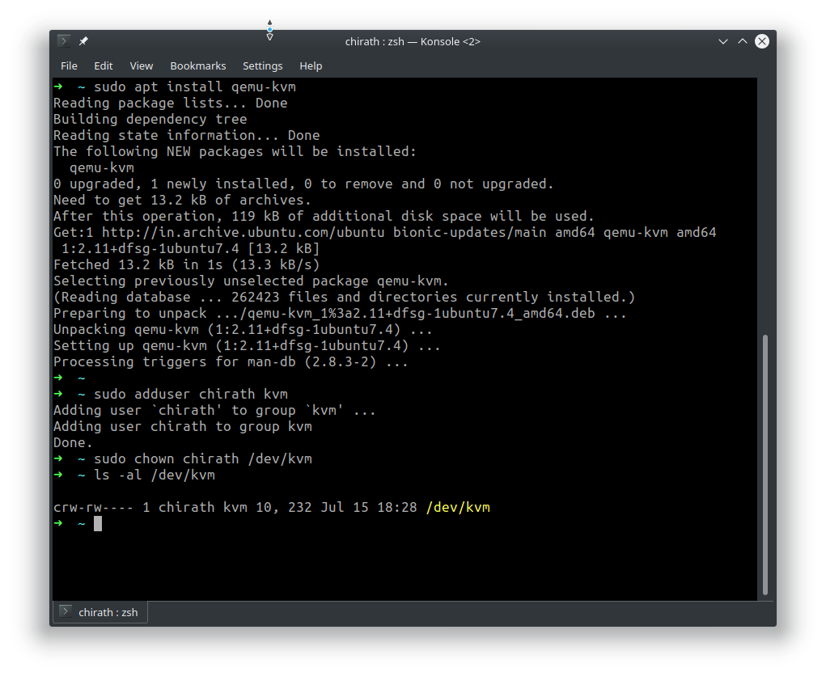
After the above steps the AVD should work as expected.
